**Docker Task -3**

**Task Description:**

Create a custom docker image for nginx and deploy it using docker compose, where the volume bind mount should be at /var/opt/nginx location. Push the created custom docker image to your docker-hub.

**Techstacks needs to be used :**

* AWS EC2
* Docker
* Docker Compose

**Docker Server created and allowed ports:**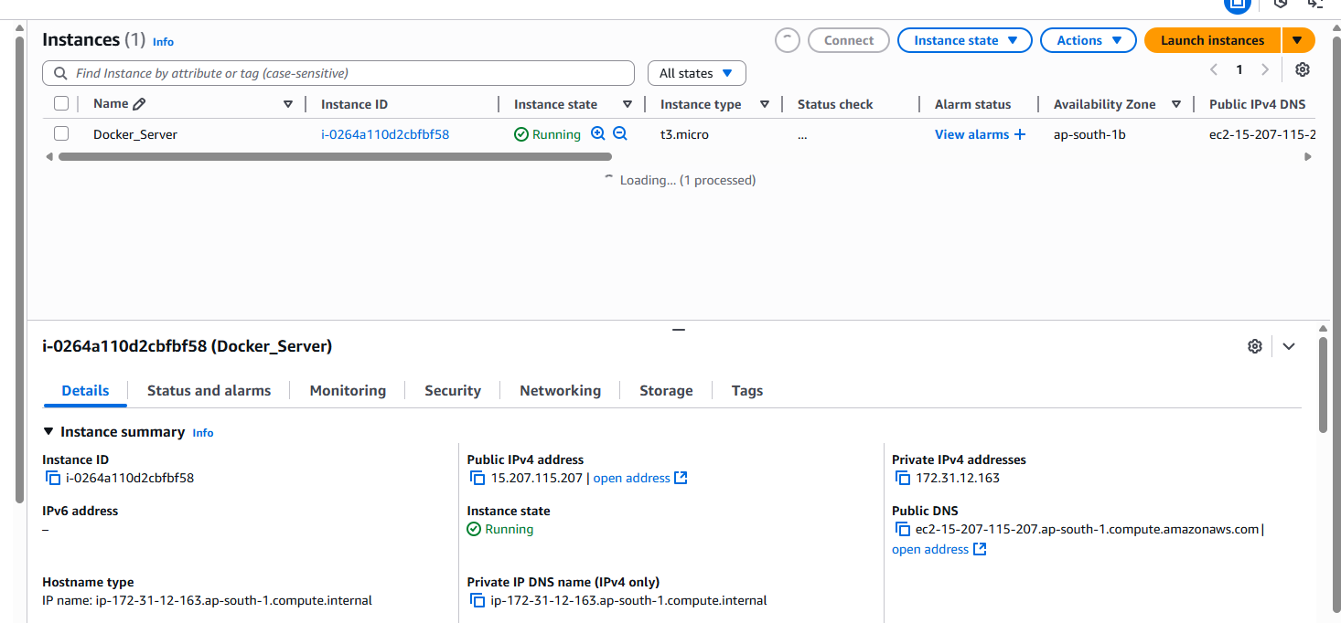

**Directory and files created:**

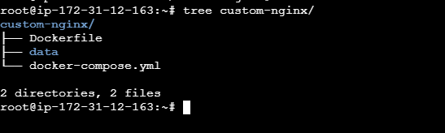 **Docker Compose and Dockerfile created: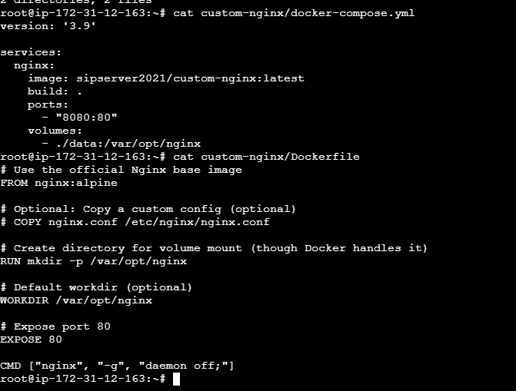 docker build -t your-dockerhub-username/custom-nginx:latest .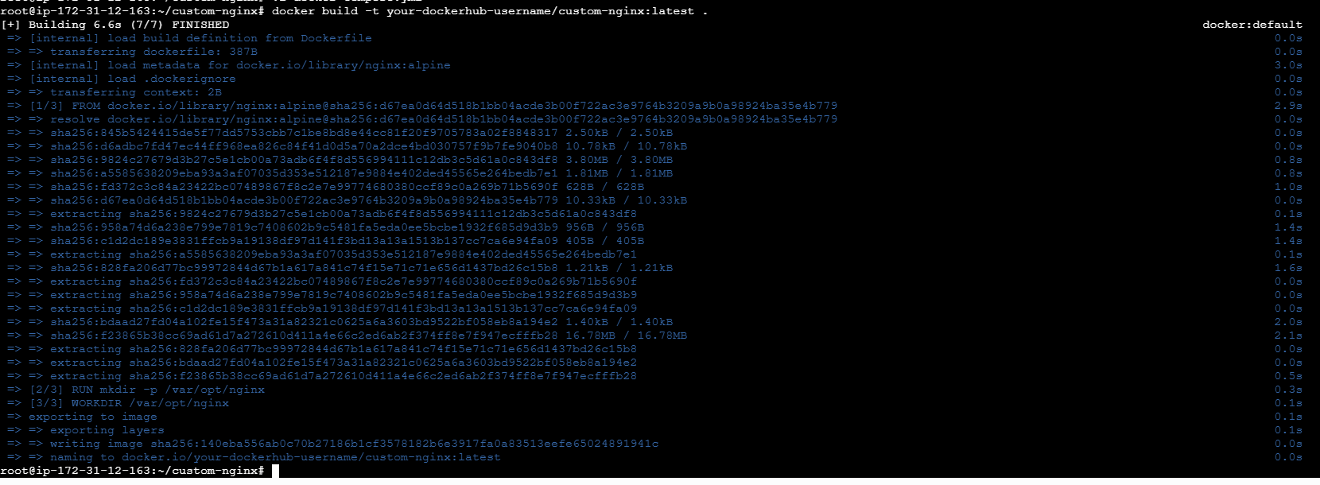 docker-compose up -d**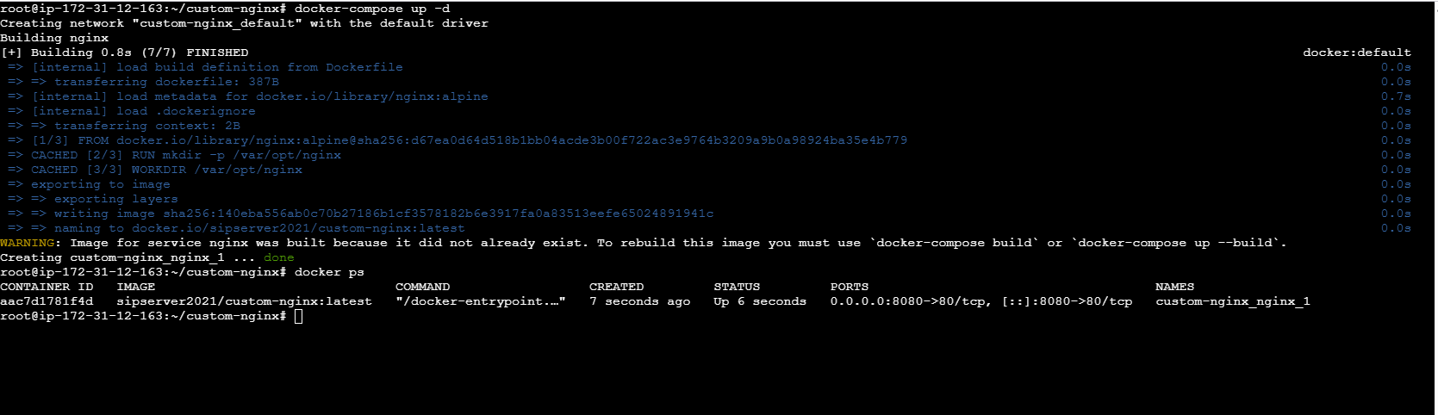

**Volumes is mounted: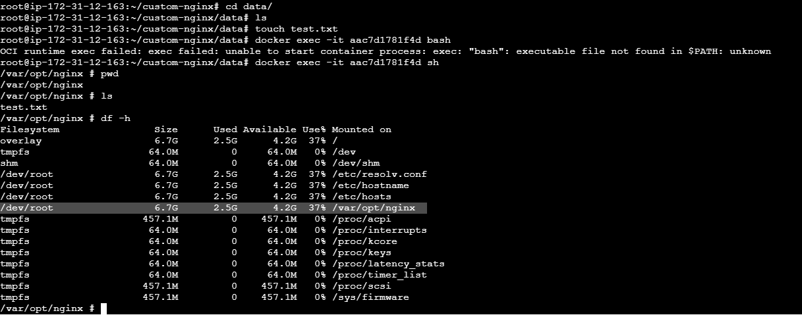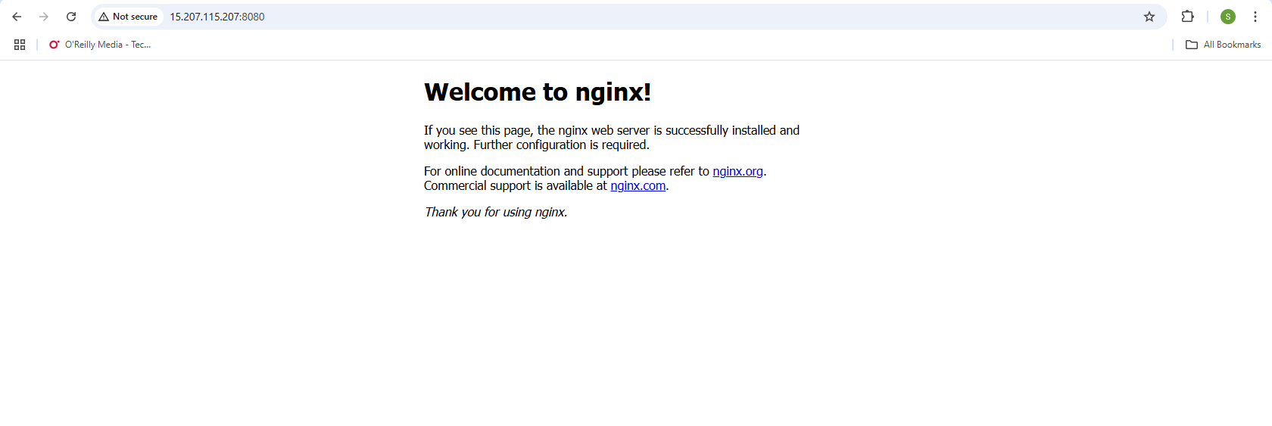 docker login:**

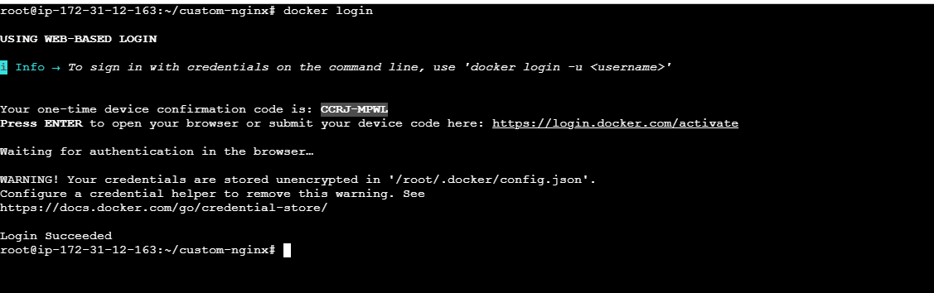 **docker push sipserver/my-custom-nginx:latest**